IoT-Based Smart Fruit Dehydrator with Multi-Fruit Presets and Automated Thermal Regulation

Submitted by:

Ciriaco, John Rudolf
Gregorio, Jahcy
Selda, Angelie A.
Tangkiyen, Almira S.

Project Overview
Project Description
The Smart IoT-Integrated Fruit Dehydrator is an innovative food preservation solution designed to address the challenges of post-harvest waste and the inefficiency of traditional sun-drying methods. In agricultural settings, rapid spoilage of seasonal fruits often leads to significant economic losses. This project provides a controlled, hygienic, and technologically advanced alternative by utilizing a vertical-flow dehydration mechanism enclosed in an industrial-grade Galvanized Iron (G.I.) chassis.
By integrating Internet of Things (IoT) capabilities through the ESP32 microcontroller, the system bridges the gap between traditional hardware and modern digital monitoring. It automates the drying process for various fruits (e.g., Mango, Banana, Apple) through pre-programmed thermal profiles and a manual customization mode, ensuring optimal nutrient retention and shelf-life extension. The system utilizes a high-capacity, low-voltage (12V) dual-PTC ceramic heating system (200W) and a high-speed circulatory fan to ensure even heat distribution through forced convection.
Unlike traditional designs, this prototype features a versatile control interface. It includes a local Human-Machine Interface (HMI) consisting of a seven-button tactile matrix and a 20x4 I2C LCD, allowing users to either select fruit presets or manually set target temperature and humidity levels directly on the device. For remote accessibility, real-time data is synchronized via Firebase Realtime Database, enabling users to monitor internal conditions and remaining drying time through a custom-built IoT mobile application. This integration ensures high data persistence and provides a localized, data-driven solution for small-scale fruit preservation, combining robust hardware with a flexible, user-centric control system.

Problem Statement

Traditional fruit drying in small-scale setups is often inefficient, inconsistent, and highly labor-intensive. Because different fruit types possess unique sugar contents and water activities, they require specific thermal environments to preserve nutritional value and texture.
The study aims to address the following specific problems:
- Inconsistent Quality Due to Static Thermal Settings
Different fruits require distinct temperature ranges to avoid case hardening or vitamin degradation. Without a regulated, multi-preset and manually adjustable system, fruits are often exposed to a single temperature, leading to poor product quality.
- Structural Degradation in Non-Industrial Enclosures
Many small-scale prototypes use wood or plastic, which degrade due to heat or fail to retain internal temperature. There is a critical need for a rugged, Galvanized Iron (G.I.) enclosure that offers durability and better heat reflection.
- Weather Dependency and Lack of Controlled Environment
Traditional sun-drying is affected by ambient humidity and weather changes. High external humidity can halt the drying process, leading to fungal growth and significant post-harvest fruit spoilage.
- Labor-Intensive Monitoring and "Monitoring Fatigue"
Manual drying requires constant human intervention to check the fruit’s state. This process is prone to "monitoring fatigue," where human error leads to scorched or unevenly dried batches.
- Limited User Interaction and Control Flexibility
Many automated dryers lack a physical interface for on-site adjustments. There is a need for a tactile button-controlled system that allows users to override presets and manually set parameters like temperature and humidity without relying solely on a mobile app.
- Absence of Real-Time Data and Historical Logs
Small-scale dryers usually provide no live feedback. Users cannot access historical data or live trends regarding how temperature and humidity fluctuations affect specific fruit varieties over a drying cycle.
- Safety Concerns with High-Voltage Components
The use of 220V AC heating elements in DIY or small-scale prototypes poses a significant risk of electric shock or fire. There is a need to transition to a low-voltage (12V) DC system to ensure operational safety for home-based and small-farm applications.

Objectives

General Objective

To develop an IoT-based smart multi-fruit dehydrator enclosed in a Galvanized Iron (G.I.) chassis, featuring a tactile button-controlled interface and a high-capacity 12V thermal system, to automate temperature regulation and drying duration through fruit-specific presets and manual customization for enhanced small-scale fruit preservation.Specific Objectives

The study aims to achieve the following objectives:
- To develop an automated IoT-based drying system that minimizes manual labor and constant supervision, improving operational efficiency for small-scale users.
- To implement a precise multi-fruit temperature control mechanism using an ESP32 microcontroller and DHT21 sensors, allowing the system to automatically adjust thermal settings for fruits like mango, banana, and apple.
- To engineer a durable and heat-efficient structural enclosure using Galvanized Iron (G.I.) sheets to provide an industrial-grade prototype that ensures structural integrity and superior heat retention.
- To optimize heat distribution through a 12V forced-convection system, utilizing a high-speed circulatory fan and passive moisture vents to ensure a continuous and even flow of dry air across the drying trays.
- To design a physical control interface using a seven-button tactile matrix, enabling users to navigate menus, select fruit presets, and manually input target temperature and humidity values.
- To provide immediate local feedback through a 20x4 I2C LCD, displaying an interactive menu for parameter setup, active countdown timers, and real-time sensor readings.
- To ensure operational safety and energy efficiency by utilizing a high-wattage 12V-powered thermal system with an automated shut-off cycle to prevent over-drying and minimize energy waste.
- To promote the utilization of IoT technologies in food processing by designing a cost-effective, scalable, and user-friendly automated solution for local farmers and home-based processors.

Scope and Limitations

Scope of the Study
This study focuses on the design, development, and implementation of an IoT-based smart multi-fruit dehydrator intended to automate temperature regulation and monitor drying duration through fruit-specific presets and user-defined parameters. The system utilizes an IoT-enabled device to capture internal environmental data, transmitting it to a centralized digital platform for real-time monitoring and analysis.
Specifically, the scope of the study includes the following:
- The use of an ESP32 microcontroller and DHT21 temperature and humidity sensors to capture real-time drying parameters and provide feedback for the automated control logic.
- Implementation of a multi-fruit preset system and a manual customization mode encoded in the microcontroller. This allows users to either select pre-defined fruit profiles (e.g., Mango, Banana, Apple) or manually input specific target temperature and humidity thresholds.
- Development of a tactile control matrix consisting of seven (7) push buttons (Set, Cancel, and five Fruit Presets) for on-site navigation and parameter adjustment without reliance on a mobile device.
- Automation of the heating mechanism involving a relay-controlled 12V dual-PTC ceramic heating system (200W) and a high-speed circulatory fan to maintain consistent heat distribution through forced convection and passive moisture venting.
- Integration of a 20x4 I2C LCD that provides an interactive menu for setup, real-time sensor readings, and process status.
- Construction of an industrial-grade prototype made of Galvanized Iron (G.I.) sheets, featuring a 16x16x20-inch chassis with a dedicated electronics compartment to isolate sensitive components from internal heat.
The study is limited to demonstrating the technical feasibility and effectiveness of the proposed smart multi-fruit dehydrator as a localized food processing solution. It does not aim to replace large-scale industrial dehydrators but rather to provide a functional, data-driven prototype suitable for small-scale farmers, researchers, and home-based fruit processors

Limitations of the Study
Despite its intended functionality, the proposed system has several limitations that should be acknowledged. Specifically, the limitations of the study include the following:
- First, the system’s real-time IoT functionality is dependent on a stable internet connection. In cases of network interruption or poor connectivity, the transmission of temperature and humidity data to the Firebase cloud dashboard may be delayed, although local monitoring via the LCD remains functional.
- Second, the accuracy of the automated drying cycle relies on the calibration and placement of the DHT21 sensor. Factors such as the sensor's proximity to the G.I. walls or the accumulation of moisture in specific corners of the chamber may affect the precision of the thermal readings.
- Third, the system does not include advanced moisture-sensing probes inside the fruit itself. The "target dryness" is estimated based on the ambient humidity inside the chamber and the pre-set duration, rather than the internal water activity of each individual fruit slice.
- Fourth, the system is designed primarily for small-scale or batch-level deployment. Large-scale industrial integration, such as linking with commercial factory management systems or high-volume conveyor-type dehydrators, is beyond the scope of this study.
- Fifth, the system's thermal efficiency is limited by the insulation properties of the Galvanized Iron (G.I.) chassis. Without advanced double-walled vacuum insulation, the power consumption and drying time may be influenced by the external ambient temperature of the surrounding environment.

System Architecture
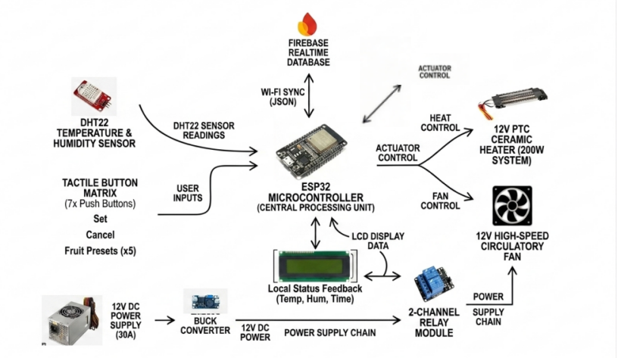



Figure 1: System Architecture

Architecture Description
The system architecture illustrates the interaction between the sensor hardware, the ESP32 microcontroller, cloud-based data synchronization, and the tactile user interface. The design follows a hybrid IoT architecture, where local automation (via physical buttons) and remote monitoring (via Firebase) work in tandem to ensure an efficient dehydration process.
- Environmental Data Acquisition
The process begins with the DHT21 sensor, which continuously captures the internal temperature and humidity levels inside the G.I. chassis. These parameters are forwarded to the ESP32 microcontroller, which serves as the central processing unit for the automated control logic.
- Physical User Interaction (Tactile Interface)
Unlike standard automated systems, this architecture incorporates a seven-button tactile matrix. The user interacts directly with the system by selecting a fruit preset (Mango, Banana, Apple) or by manually setting the target temperature and humidity. These inputs are processed by the ESP32 to define the system's operational state.
- Relay-Controlled Thermal Actuation
Upon receiving the control parameters, the ESP32 triggers the Relay Module to activate the 12V PTC Ceramic Heating System. The system manages power distribution to the 200W heaters to reach and maintain the required thermal setpoint.
- Forced Convection and Heat Distribution
To ensure an optimized drying environment, the ESP32 activates the 12V High-Speed Circulatory Fan. This ensures that heat is evenly distributed across the fruit trays through forced convection, while moisture is managed through passive venting.
- Local Visual Feedback (I2C LCD)
The 16x2 I2C LCD serves as the primary local display. It retrieves live data from the ESP32 to show the current temperature, humidity, and the active countdown timer. It also provides an interactive menu during the parameter setup phase.
- Firebase Cloud Synchronization
The ESP32 utilizes its built-in Wi-Fi module to synchronize all operational data to the Firebase Realtime Database. This includes the live sensor readings, the current status of the heater, and the remaining drying time.
- Remote Monitoring via Mobile Application
Authorized users can access the system's status through a custom-built IoT mobile application. The app fetches real-time updates from Firebase, allowing the user to monitor the dehydration process remotely without needing to be physically present at the machine.
- Automated Safety Shut-off Logic
The architecture ensures data-driven safety. Once the countdown timer reaches zero or the target humidity level is achieved, the ESP32 executes a system-wide shut-off, deactivating the heaters and fans and sending a final "Process Complete" status update to both the LCD and the mobile app.

Data Flow
The data flow of the IoT-based Smart Fruit Dehydrator describes how environmental parameters and user inputs move through the system—from hardware capture to cloud synchronization and mobile presentation. Understanding this flow clarifies how the system achieves precise thermal regulation and real-time remote monitoring.
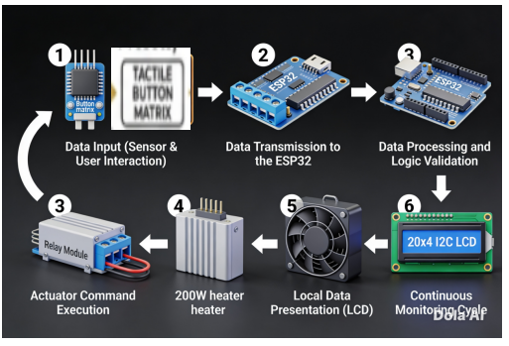



Figure 2: Data Flow

The data flow follows a structured path: Data Acquisition → Processing & Logic Execution → Actuator Command→ Local FeedbackThis ensures reliability and real-time accessibility as follows:

1.Data Input (Sensor & User Interaction)
The data flow begins at two points:
- Environmental Data: The DHT21 sensor captures raw temperature and humidity values inside the chamber.
- User Input: The user selects a fruit preset or enters manual parameters via the 7-button tactile matrix.
2. Data Transmission to the ESP32
The raw environmental data and button signals are transmitted to the ESP32 microcontroller. At this stage, the data is processed from electrical signals into digital values (Celsius for temperature and percentage for humidity).
3. Data Processing and Logic Validation
The ESP32 compares the current sensor readings against the target setpoints (either from the hardcoded fruit presets or the user’s manual input). The system applies logic checks to determine if the heaters and fans should be activated or deactivated to maintain the required environment.
4. Actuator Command Execution
Based on the processing results, the ESP32 generates output commands:
- Thermal Control: Sends a signal to the Relay Module to toggle the 200W heaters.
- Airflow Control: Maintains the operation of the circulatory fan for heat distribution.
5. Local Data Presentation (LCD)
Simultaneously, the ESP32 formats the processed data (current temp, target temp, and countdown timer) and sends it to the 20x4 I2C LCD. ito ang nagbibigay ng immediate on-site feedback para sa operator.
6.Continuous Monitoring Cycle
The data flow operates in a continuous loop. Every few seconds, the DHT21 refreshes the readings, the ESP32 re-evaluates the logic, and the cloud/local displays are updated. This cycle ensures that the system reacts instantly to any thermal changes inside the G.I. chassis.

Hardware Components
Component | Description | Minimum Requirements | Recommended Requirements
Microcontroller | Central hub for logic, fruit presets, and Wi-Fi IoT connectivity. | ESP8266 | ESP32 DevKit V1
Temp & Humidity Sensor | Monitors internal G.I. chamber climate conditions. | DHT21 | DHT22 (High Precision)
Heating Element | Provides consistent thermal energy for dehydration. | 50W Halogen Bulb | 100W-200W PTC Ceramic Heater
Relay Module | Acts as an electronic switch for high-power actuators. | 1-Channel Relay | 2-Channel Relay (5V/10A)
Circulatory Fan | Ensures forced convection and even heat distribution. | 5V DC Fan | 12V DC High-Speed Fan
Moisture Venting | Facilitates moisture exhaust through physical openings. | Small Openings | Passive Vents (Mesh Protected)
Power Supply | Converts AC wall power to regulated DC for the electronics. | 5V 2A Adapter | 12V 5A Power Supply with Step-down
Local Display | Shows real-time temperature, humidity, and countdown. | 16x2 LCD | 16x2 LCD with I2C Module
Chassis Material | Provides the heat-reflective and durable enclosure. | Plastic/Wood | Galvanized Iron (G.I.) Sheets
Wiring & Connectors | Facilitates all secure module-to-microcontroller links. | Generic Wires | Dupont Jumper Wires & Soldered Pins
Electronics Enclosure | Protective plastic casing for the ESP32, relays, and power modules to prevent short circuits and moisture damage. | Generic Plastic Box | ABS Plastic Project Box (IP65 Rated)
User Interface Buttons | Tactile switches for Preset and Manual control modes. | 3 Buttons | 7-Button Tactile Matrix

Table 1: Hardware Components

Software Components
Software | Purpose | Minimum Requirements | Recommended Requirements
Arduino IDE | Primary Integrated Development Environment for writing and uploading firmware to the ESP32.
C++ / Arduino Language | Programming logic for sensors, relays, and timers.
Table 2: Software Components

Functional Requirements
This section discusses the core functional requirements of the IoT-based Smart Fruit Dehydrator. Each requirement defines a specific behavior that the system must perform to ensure accurate, safe, and efficient fruit preservation.
1. The system shall capture environmental data
The system is required to read temperature and humidity data from the internal drying chamber using the DHT21 sensor. This automated sensing provides the real-time thermal readings necessary to maintain the environment required for specific fruit types.
2. The system shall execute fruit-specific presets
The system must allow the user to select between pre-programmed profiles (e.g., Mango, Banana, Pineapple) using the 7-button tactile matrix. Once a preset is selected, the ESP32 must automatically assign the target temperature and the required drying duration.
3. The system shall regulate thermal conditions
Based on the DHT21 feedback, the system must toggle the 200W Dual PTC Ceramic Heaters via the 2-channel relay. If the temperature falls below the setpoint, the heaters activate; if it reaches the target, they deactivate to maintain thermal consistency.
4. The system shall implement synchronized airflow
The 12V Circulatory Fan shall activate in tandem with the heating cycle to provide forced convection. This ensures that heat is distributed evenly across all trays within the 16-inch G.I. chassis, preventing "cold spots" inside the chamber.
5. The system shall run an active countdown timer
The system must track the remaining drying time through an internal software timer. This timer starts upon the selection of a preset and decrements until it reaches zero, eliminating the need for manual timekeeping.
6. The system shall provide expanded local visual feedback
The system must display the current internal climate, target setpoints, and the active countdown on a 20x4 I2C LCD. This ensures the user remains informed even if there is an internet interruption.
7. The system shall perform an automated safety shut-off
Upon the completion of the countdown timer, the system must automatically cut power to the heating elements. This prevents energy waste and ensures the fruit does not over-dry or scorch.
Non-Functional Requirements
This section defines the quality attributes of the system, focusing on how the dehydrator performs its tasks to ensure safety, accuracy, and a positive user experience.
1. Thermal Stability and Accuracy
The system is required to maintain the internal temperature within a range of ±1.5°C of the selected fruit preset. This precision is necessary to prevent nutritional degradation and ensure even dehydration of high-sugar fruits like mangoes.
4. Safety and Fail-Safe Mechanisms
The system must implement a hardware and software override that triggers an automated thermal shut-off if the internal temperature exceeds 75°C. This protects the G.I. enclosure and the electronics from potential equipment damage.
5. Structural Durability and Heat Resistance
The Galvanized Iron (G.I.) chassis must withstand repeated thermal cycles without warping or losing heat-reflective properties. All electronic components must be housed in a dedicated, ventilated compartment to prevent heat-soak from the main chamber.

System Operation Procedure
This section describes the step-by-step procedure for operating the IoT-based Smart Fruit Dehydrator. The procedure outlines the sequence of actions from hardware initialization and fruit selection to remote monitoring and automated shut-off.

Step 1: Power Initialization and Hardware Boot-up
Power Initialization and Hardware Boot-up

The system is powered by a 12V 30A Switching Power Supply. Upon startup, the ESP32 microcontroller initializes the DHT22 sensor, the 20x4 I2C LCD, the 7-button tactile matrix, and the 4-Channel Relay Module. The LCD displays a "System Ready" message once all sensors and actuators are functional.

Step 2: System Unlocking
System Unlocking

For safety and to prevent accidental activation, the system starts in a "LOCKED" state. The operator must press the designated CANCEL (Red) button to unlock the interface and proceed to the mode selection menu.

Step 3: Fruit Profile Configuration
Fruit Profile Configuration

Users select a fruit profile (e.g., Mango, Banana, or Apple) via the 7-button hardware interface or the Custom Android App. This action loads pre-programmed thermal setpoints and drying durations, initiating a countdown timer that synchronizes across both the LCD and the mobile dashboard.
Step 4: Activation of Heating and Ventilation
Activation of Heating and Ventilation

The ESP32 triggers the 4-Channel Relay to activate the 200W Dual PTC Ceramic Heaters and the 12V High-Speed Blower. This begins the immediate circulation of air within the G.I. chassis.

Step 5: Automated Thermal Feedback Loop
Automated Thermal Feedback Loop

The system continuously monitors internal temperature via the DHT22. If the temperature is below the setpoint, the ESP32 keeps the heater relays active. The forced convection from the blower ensures uniform heat distribution across all drying trays.

Step 6:Moisture Management and Airflow Interval
IoT Monitoring and Moisture Management

The system manages moisture by operating the blower fan on a programmed interval (e.g., 45 seconds of active airflow). This ensures that moisture-laden air is effectively expelled through ventilation ports while maintaining energy efficiency.
Step 7: Automated Shut-off and Completion Notification
Automated Shut-off and Completion Notification

When the timer reaches zero, the ESP32 executes a system-wide shut-off of the heaters and blower. It sends a "Drying Complete" status to Firebase, updates the local LCD, and pushes a real-time notification to the user’s smartphone.

Gantt Chart
SELDA
Task / Phase | Week 1 | 2 | 3 | 4 | 5 | 6 | 7 | 8
Project Planning & Proposal | ███ | ███
Document Making |  | ███ | ███
Hardware Canvassing |  |  | ███
Hardware Buying / Procurement |  |  | ███ | ███
G.I. Chassis Fabrication |  |  |  | ███ | ███
Heater & Fan Logic Integration |  |  |  |  | ███
Wiring & Assembly & Firmware Development (ESP32) |  |  |  |  | ███ | ███
Application Development (IoT) |  |  |  |  |  | ███ | ███
Performance Testing & Debugging |  |  |  |  |  |  | ███ | ███

GREGORIO
Task / Phase | Week 1 | 2 | 3 | 4 | 5 | 6 | 7 | 8
Project Planning & Proposal | ███ | ███
Data flow diagram Preparation |  | ███ | ███ | ███
Research Components for needed |  |  | ███ | ███
Ordering Requirements/ Materials |  |  |  | ███ | ███
Coordination with Group Mambers | ███ | ███ | ███ | ███ | ███ | ███ | ███ | ███
Documentation Support | ███ | ███ | ███ | ███ | ███ | ███ | ███ | ███
Testing |  |  |  |  |  |  | ███ | ███

TANGKIYEN
Task / Phase | Week 1 | 2 | 3 | 4 | 5 | 6 | 7 | 8
Project Planning & Proposal | ███ | ███
System Architecture Preparation |  | ███ | ███ | ███
Research Components for ordering |  |  | ███ | ███
Coordination with the group | ███ | ███ | ███ | ███ | ███ | ███ | ███ | ███
Document Support | ███ | ███ | ███ | ███ | ███ | ███ | ███ | ███
Performance Testing |  |  |  |  |  |  | ███ | ███

Expected Output
The expected outputs of the IoT-Based Smart Fruit Dehydrator are the sum of its hardware integration and software intelligence, designed to provide a seamless food preservation experience. The following results are expected upon the completion of the system:
1. Automated Thermal and Airflow Regulation
The system generates a fully automated environment where the 200W Dual PTC Ceramic Heaters and the Circulatory Fan are regulated by the ESP32 logic. This eliminates the need for manual temperature checking and ensures a stable internal climate throughout the drying process.
2. Synchronized Convection Control
A key output is the intelligent activation of the 12V High-Speed Circulatory Fan, which operates in synchronization with the heating elements. This ensures that thermal energy is immediately distributed through forced convection, preventing localized overheating and ensuring uniform drying across all trays within the G.I. chassis.
3. Multi-Fruit Dehydration Presets
The system provides pre-programmed thermal profiles for various fruits (e.g., Mango, Banana, Pineapple, etc.) accessible via the 7-button tactile matrix or the mobile app. This ensures that each fruit type is dried at its optimal temperature and duration, preserving nutritional value while preventing over-drying.
- Local Visual Feedback System
The integration of a 20x4 I2C LCD provides an expanded on-site interface. This output ensures that the operator can verify the system's status, target setpoints, and live countdown timer simultaneously, even without smartphone access or an active internet connection.
5. Industrial-Grade G.I. Structural Prototype
The final physical output is a rugged, 16-inch Galvanized Iron (G.I.) structural prototype. The enclosure is designed for superior heat reflection and durability, featuring a dedicated electronics compartment to protect the ESP32 and relays from high-heat exposure.
6. Automated Status and Completion Notifications
The system is expected to push real-time notifications to the user’s mobile device upon the successful completion of a drying cycle or if a safety thermal threshold is reached. This ensures a "set-and-forget" operation, providing peace of mind for small-scale food processors and home users.

Development Period
The development period refers to the actual time span during which the IoT-Based Smart Fruit Dehydrator was designed, fabricated, programmed, and finalized. For this project, the development period covered eight (8) weeks, starting from initial planning and chassis design up to the final evaluation of the automated drying cycles.
During this period, all major activities—including the industrial-grade G.I. fabrication, ESP32 firmware development, Firebase Realtime Database integration, and the calibration of fruit-specific thermal profiles—were completed according to the systematic engineering process. Documenting the development period ensures that the structural and electronic integrity of the prototype met the academic and functional standards.

Recommended Development Photos for the Dehydrator:
1.Chassis Fabrication Photos
Images showing the cutting, bending, and assembly of the 16-inch Galvanized Iron (G.I.) sheets, including the installation of the tray sliders and the electronics compartment.
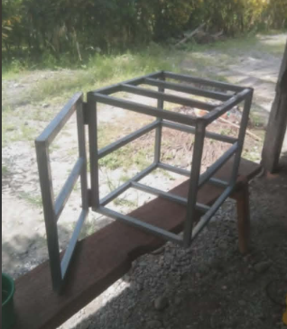
2.Hardware & Wiring Integration
Photos of the ESP32, DHT21 sensor, and the 2-Channel Relay during the wiring process, specifically showing the connection to the 200W Dual PTC Ceramic Heaters.
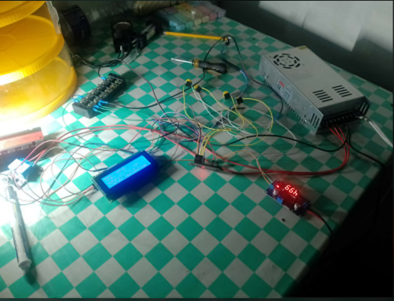

3.UI/UX Development
Photos showing the integration of the 7-button tactile matrix and the mounting of the 20x4 I2C LCD on the control panel.
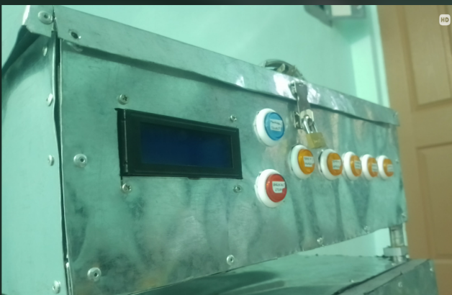

5.Thermal Calibration Activities:
Photos of the system running an actual test cycle, showing the local LCD displaying the active countdown timer and real-time internal climate.
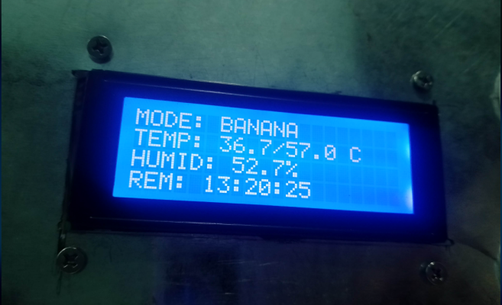

Proof of System Functionality
To strengthen the project’s credibility and verify that all functional requirements were met, the following proofs are provided:

1. Real-Time Local Feedback Logs
- LCD Status Documentation: Photos of the 20x4 LCD showing live updates of temperature, humidity, and timer values during a full drying cycle.
- Demonstrates real-time data capture: Confirms that the ESP32 successfully transmits environmental data to the cloud with minimal latency.
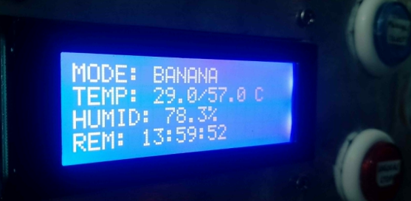
2. Firmware Logic and Code Structure
- Excerpts of ESP32 Firmware: Showing the logic for fruit-specific presets (Mango, Apple, Banana) and I2C LCD communication.
- Technical Implementation: Provides evidence of the programmed logic used to control the heaters, the 45-second blower intervals, and the 7-button matrix.
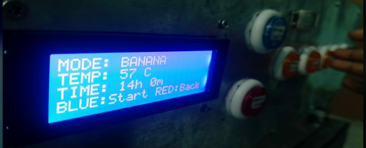
3. Progressive Hardware Iterations
- Iterative Code Development: Saved versions of the Arduino sketches across the 8-week development period, showing the transition from basic sensor reading to complex system logic.
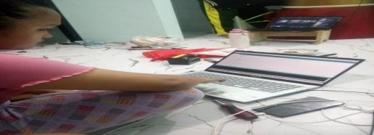
- Confirms Systematic Development: Proves that the project underwent rigorous testing, including the troubleshooting of hardware failures and electrical interference.

4. Structural Heat Retention Test Results
- Thermal Stability Tables: Screenshots or tables comparing target fruit temperatures versus actual internal readings.
- Confirms Requirement Fulfillment: Validates that both functional (automatic dehydration) and non-functional (thermal accuracy) requirements were successfully met.
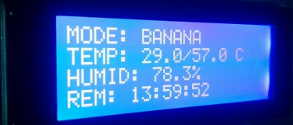

Source Code

#include <Arduino.h>
#include <Wire.h>
#include <LiquidCrystal_I2C.h>
#include "DHT.h"

// --- PINS ---
#define PIN_DHT 4
#define PIN_SELECT 12
#define PIN_CANCEL 13
#define PIN_MANGO 14
#define PIN_APPLE 25
#define PIN_BANANA 26
#define PIN_ORANGE 27
#define PIN_GRAPES 33
#define PIN_BLOWER 5
#define PIN_HEATER_1 18
#define PIN_HEATER_2 19

DHT dht(PIN_DHT, DHT21);
LiquidCrystal_I2C lcd(0x27, 20, 4);

enum State { WELCOME, LOCKED, MODE_SELECT, PRESET_VIEW, MANUAL_SET, DRYING, STOP_CONFIRM, FINISHED_CONFIRM };
State currentState = WELCOME;

float temp = 0, hum = 0;
int targetTemp = 35;
int targetTimeHrs = 1;
int targetTimeMins = 0;
unsigned long startTime = 0;
unsigned long totalSeconds = 0;
String fruitName = "IDLE";
bool isRunning = false;
bool adjustMinutes = false;
unsigned long lastLCDUpdate = 0;
State lastState = WELCOME;

// --- BLOWER LOGIC ---
unsigned long lastBlowerToggle = 0;
bool intervalBlowerActive = false;
const unsigned long BLOWER_OFF_DURATION = 2700000; // 45 mins
const unsigned long BLOWER_ON_DURATION = 10000; // 10 secs

// --- SAFETY & DEBOUNCE ---
const unsigned long DEBOUNCE_DELAY = 50;
const float MAX_SAFETY_TEMP = 75.0; // Hard limit

void startDrying();
void stopDrying(String reason);
void updateLCDOperation();
void handleHardware();
void refreshStaticText();

bool isButtonPressed(int pin) {
if (digitalRead(pin) == LOW) {
delay(DEBOUNCE_DELAY);
if (digitalRead(pin) == LOW) return true;
}
return false;
}

void setup() {
Serial.begin(115200);
int inputPins[] = {PIN_SELECT, PIN_CANCEL, PIN_MANGO, PIN_APPLE, PIN_BANANA, PIN_ORANGE, PIN_GRAPES};
for(int p : inputPins) pinMode(p, INPUT_PULLUP);

pinMode(PIN_BLOWER, OUTPUT);
pinMode(PIN_HEATER_1, OUTPUT);
pinMode(PIN_HEATER_2, OUTPUT);

digitalWrite(PIN_BLOWER, LOW);
digitalWrite(PIN_HEATER_1, LOW);
digitalWrite(PIN_HEATER_2, LOW);

dht.begin();
lcd.init();
lcd.backlight();
}

void loop() {
float t = dht.readTemperature();
float h = dht.readHumidity();
if (!isnan(t)) temp = t;
if (!isnan(h)) hum = h;

if (currentState != lastState) {
lcd.clear();
refreshStaticText();
lastState = currentState;
}

switch (currentState) {
case WELCOME:
lcd.setCursor(6, 1); lcd.print("WELCOME!");
lcd.setCursor(2, 2); lcd.print("Smart Dehydrator");
delay(2000);
currentState = LOCKED;
break;

case LOCKED:
if (isButtonPressed(PIN_CANCEL)) { currentState = MODE_SELECT; }
break;

case MODE_SELECT:
if (isButtonPressed(PIN_MANGO)) { fruitName="MANGO"; targetTemp=57; targetTimeHrs=12; targetTimeMins=0; currentState=PRESET_VIEW; }
if (isButtonPressed(PIN_APPLE)) { fruitName="APPLE"; targetTemp=57; targetTimeHrs=10; targetTimeMins=0; currentState=PRESET_VIEW; }
if (isButtonPressed(PIN_BANANA)) { fruitName="BANANA"; targetTemp=57; targetTimeHrs=14; targetTimeMins=0; currentState=PRESET_VIEW; }
if (isButtonPressed(PIN_ORANGE)) { fruitName="ORANGE"; targetTemp=57; targetTimeHrs=15; targetTimeMins=0; currentState=PRESET_VIEW; }
if (isButtonPressed(PIN_GRAPES)) { fruitName="GRAPES"; targetTemp=57; targetTimeHrs=30; targetTimeMins=0; currentState=PRESET_VIEW; }
if (isButtonPressed(PIN_SELECT)) { fruitName="MANUAL"; targetTemp=35; targetTimeHrs=1; targetTimeMins=0; currentState=MANUAL_SET; }
if (isButtonPressed(PIN_CANCEL)) { currentState=LOCKED; }
break;

case MANUAL_SET:
lcd.setCursor(6, 1); lcd.print(targetTemp); lcd.print("C ");
lcd.setCursor(6, 2); lcd.print(targetTimeHrs); lcd.print("h "); lcd.print(targetTimeMins); lcd.print("m ");
lcd.setCursor(0, 3); lcd.print(adjustMinutes ? "MOD: MINS " : "MOD: HOURS");

// --- TEMPERATURE LOOP LOGIC (35 to 75) ---
if (isButtonPressed(PIN_MANGO)) {
targetTemp -= 5;
if(targetTemp < 35) targetTemp = 75; // Loop back to 75
delay(150);
}
if (isButtonPressed(PIN_APPLE)) {
targetTemp += 5;
if(targetTemp > 75) targetTemp = 35; // Loop back to 35
delay(150);
}

if (isButtonPressed(PIN_GRAPES)) { adjustMinutes = !adjustMinutes; delay(250); }

if (adjustMinutes) {
if (isButtonPressed(PIN_BANANA)) { targetTimeMins -= 5; if(targetTimeMins < 0) targetTimeMins = 55; delay(150); }
if (isButtonPressed(PIN_ORANGE)) { targetTimeMins += 5; if(targetTimeMins >= 60) targetTimeMins = 0; delay(150); }
} else {
if (isButtonPressed(PIN_BANANA)) { if(targetTimeHrs > 0) targetTimeHrs -= 1; delay(150); }
if (isButtonPressed(PIN_ORANGE)) { if(targetTimeHrs < 99) targetTimeHrs += 1; delay(150); }
}
if (isButtonPressed(PIN_SELECT)) { startDrying(); }
if (isButtonPressed(PIN_CANCEL)) { currentState=MODE_SELECT; }
break;

case PRESET_VIEW:
if (isButtonPressed(PIN_SELECT)) { startDrying(); }
if (isButtonPressed(PIN_CANCEL)) { currentState=MODE_SELECT; }
break;

case DRYING:
handleHardware();
if (millis() - lastLCDUpdate > 1000) {
updateLCDOperation();
lastLCDUpdate = millis();
}
if (isButtonPressed(PIN_CANCEL)) { currentState = STOP_CONFIRM; }
if ((millis() - startTime) / 1000 >= totalSeconds) { stopDrying("FINISHED"); }
break;

case STOP_CONFIRM:
if (isButtonPressed(PIN_SELECT)) { stopDrying("IDLE"); }
if (isButtonPressed(PIN_CANCEL)) { currentState=DRYING; }
break;

case FINISHED_CONFIRM:
if (isButtonPressed(PIN_SELECT)) { currentState = MODE_SELECT; }
break;
}
}

void refreshStaticText() {
switch (currentState) {
case LOCKED:
lcd.setCursor(3, 1); lcd.print("SYSTEM LOCKED");
lcd.setCursor(2, 2); lcd.print("Tap RED to Unlock");
break;
case MODE_SELECT:
lcd.setCursor(4, 0); lcd.print("SELECT MODE");
lcd.setCursor(0, 1); lcd.print("BLUE:Man FRUIT:Pre");
lcd.setCursor(0, 3); lcd.print("RED: Lock System");
break;
case MANUAL_SET:
lcd.setCursor(0, 0); lcd.print("MODE: MANUAL SET");
lcd.setCursor(0, 1); lcd.print("TEMP: ");
lcd.setCursor(0, 2); lcd.print("TIME: ");
break;
case PRESET_VIEW:
lcd.setCursor(0, 0); lcd.print("MODE: " + fruitName);
lcd.setCursor(0, 1); lcd.print("TEMP: "); lcd.print(targetTemp); lcd.print(" C");
lcd.setCursor(0, 2); lcd.print("TIME: "); lcd.print(targetTimeHrs); lcd.print("h "); lcd.print(targetTimeMins); lcd.print("m");
lcd.setCursor(0, 3); lcd.print("BLUE:Start RED:Back");
break;
case STOP_CONFIRM:
lcd.setCursor(2, 0); lcd.print("STOP PROCESS?");
lcd.setCursor(0, 1); lcd.print("BLUE: YES (Stop)");
lcd.setCursor(0, 2); lcd.print("RED: NO (Resume)");
break;
case FINISHED_CONFIRM:
lcd.setCursor(2, 0); lcd.print("DRYING COMPLETE!");
lcd.setCursor(0, 2); lcd.print("Tap BLUE Button");
lcd.setCursor(0, 3); lcd.print("to Confirm & Reset");
break;
}
}

void startDrying() {
isRunning = true;
startTime = millis();
intervalBlowerActive = false;
lastBlowerToggle = millis();
totalSeconds = ((unsigned long)targetTimeHrs * 3600) + ((unsigned long)targetTimeMins * 60);
currentState = DRYING;
}

void stopDrying(String reason) {
isRunning = false;
digitalWrite(PIN_BLOWER, LOW);
digitalWrite(PIN_HEATER_1, LOW);
digitalWrite(PIN_HEATER_2, LOW);

if(reason == "FINISHED") {
currentState = FINISHED_CONFIRM;
} else {
fruitName = "IDLE";
currentState = LOCKED;
}
}

void updateLCDOperation() {
unsigned long elapsedSecs = (millis() - startTime) / 1000;
unsigned long remainingSecs = (totalSeconds > elapsedSecs) ? totalSeconds - elapsedSecs : 0;
int h = remainingSecs / 3600;
int m = (remainingSecs % 3600) / 60;
int s = remainingSecs % 60;

lcd.setCursor(0, 0); lcd.print("MODE: "); lcd.print(fruitName); lcd.print(" ");
lcd.setCursor(0, 1); lcd.print("TEMP: "); lcd.print(temp, 1);
lcd.print("/"); lcd.print((float)targetTemp, 1); lcd.print(" C ");
lcd.setCursor(0, 2); lcd.print("HUMID: "); lcd.print(hum, 1); lcd.print("% ");
char timerBuf[20];
sprintf(timerBuf, "REM: %02d:%02d:%02d", h, m, s);
lcd.setCursor(0, 3); lcd.print(timerBuf);
}

void handleHardware() {
if (!isRunning) return;

if (temp >= MAX_SAFETY_TEMP) {
digitalWrite(PIN_HEATER_1, LOW);
digitalWrite(PIN_HEATER_2, LOW);
}
else if (temp < (float)targetTemp) {
digitalWrite(PIN_HEATER_1, HIGH);
digitalWrite(PIN_HEATER_2, HIGH);
}
else {
digitalWrite(PIN_HEATER_1, LOW);
digitalWrite(PIN_HEATER_2, LOW);
}

unsigned long currentMillis = millis();
if (!intervalBlowerActive) {
if (currentMillis - lastBlowerToggle >= BLOWER_OFF_DURATION) {
intervalBlowerActive = true;
lastBlowerToggle = currentMillis;
digitalWrite(PIN_BLOWER, HIGH);
} else {
digitalWrite(PIN_BLOWER, LOW);
}
} else {
if (currentMillis - lastBlowerToggle >= BLOWER_ON_DURATION) {
intervalBlowerActive = false;
lastBlowerToggle = currentMillis;
digitalWrite(PIN_BLOWER, LOW);
} else {
digitalWrite(PIN_BLOWER, HIGH);
}
}
}

